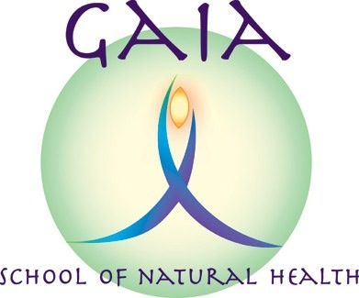
Aromatherapy Diploma
Application Form September 2019 entry

Name:
(Please enter your legal name, per birth certificate or passport)
Name you would like us to use:

Address:

Contact Phone Number Home:
Contact Phone Number Mobile:
E-mail:
Date of birth:

The information requested in this application form are for legitimate purposes.
The Privacy and Data protection policy notice is available on the Gaia School of Natural Health website.

If you would like to opt-in to receive Gaia School mailshots please provide your consent by providing your name here:
______________________________

How did you hear about the Gaia School? (If via internet, which site did you use or what search did you do?)

Current roles and responsibilities: (Please include here details of any paid or unpaid work you undertake, with dates, and family or community roles. I want to get a feel for the current commitments you have.)

Previous roles and responsibilities, including past employment, with dates:

Academic Qualifications/training obtained, please give dates:

For “qualified therapist” applicants, please provide evidence (a copy) of qualifications that provide exemption.

Do you have any special requirements in terms of access, learning needs etc?

Do you have any medical conditions of which the tutor should be aware, or which might affect your ability to fully take part in the diploma?

Please provide a contact name and number in the event of an emergency:
Name
Contact number

Please reserve me a place(s) on:
Course | Course fees | No. of Places
Aromatherapy  Diploma | Full diploma course: £1,400  Non-refundable deposit: £250.  Followed by  - £1,150 one-off balance payment at start of course OR  - 5 monthly payments £230 per monthly standing order subject to terms.
Aromatherapy  Diploma  (non-qualified therapist) | Full diploma course: £1,550  Non-refundable deposit £250  Followed by  - £1,300 one-off balance payment at start of course OR  - 5 monthly payments £260 per monthly standing order subject to terms.
Closing date for bookings: Thursday 12th September

Please send this form to: Carolyn Roberts, Gaia School of Natural Health, 15 Grange Crescent, Childer Thornton, South Wirral, CH66 5NA.
Or email to gaia@carolynroberts.co.uk

Please enclose a cheque for £250 made payable to “Gaia School of Natural Health”. This is a non-refundable deposit for the aromatherapy course, which will only be returned if the course is cancelled by the Gaia School. Or you can make a bank transfer to Sort code: 089299
Account No.: 69643259

On a separate sheet of paper (or overleaf), please answer the following questions, in around 250 words:

Why do you wish to train as an aromatherapist, and what qualities do you possess that would make you a good therapist?

