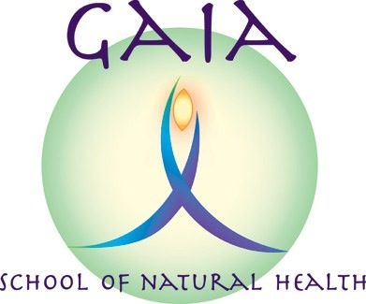
GAIA AROMAREFLEX
AROMATHERAPY FOR
REFLEXOLOGISTS
Information and Booking Form

Led by: CAROLYN ROBERTS MAR MSc PRM. Principal of Gaia School of Natural Health
Date: Tuesday 12th June 2018
Time: 9.30am – 4.30pm
Venue: The Women's Institute, Neston Road, Thornton Hough,
South Wirral, CH63 1JW.

Suitable for qualified reflexologists (recognized Level 3 qualification or higher) with little or no previous knowledge or experience of aromatherapy. This hands-on workshop will introduce you to aromatherapy and how it can be safely incorporated into your reflexology treatments.
You will learn about aromatherapy and be introduced to 12 specific essential oils and their safe use. You will be shown how to make up a foot cream blend for use in your reflexology treatments or for your clients to use at home. The workshop will also cover other ways that aromatherapy may be incorporated into your reflexology.
The cost of this course is £95.00, and this includes all aromatherapy essential oils, creams, bottles etc for use in the workshop, course handouts, and light refreshments. Please bring a packed lunch.
Balens insurance have confirmed that they will accept this certificate in order to insure reflexologists to use these named oils in their treatments. In order to satisfy CPD training requirements you will be required to submit 5 follow up treatments in order to obtain your certificate.

How do I book?

Please complete and return the slip attached with your non-refundable deposit for £40 to Gaia School of Natural Health. The deposit is non-refundable unless the course is cancelled by the Gaia School. The form can be e-mailed back, and the deposit can be paid online.

GAIA AROMAREFLEX
(AROMATHERAPY FOR REFLEXOLOGISTS) BOOKING FORM

Please reserve me a place on:

Course | Date(s) | No. of Places
GAIA AROMAREFLEX  (AROMATHERAPY FOR  REFLEXOLOGISTS)  £95 per person | Tuesday 12th June 2018  Times: 9.30am to 4.30pm

Closing date for bookings: Tuesday 5th June 2018

Please make a bank transfer for £40 non-refundable deposit (balance of £55 to be paid on the day) to “Gaia School of Natural Health” Sort code: 089299. Account No.: 69643259.
Or please make cheques payable to “Gaia School of Natural Health” and send to 15 Grange Crescent, Childer Thornton, S. Wirral, CH66 5NA.

NB: Students are required to have a recognised qualification in Reflexology to Practitioners Diploma level 3 (minimum)

PLEASE PRINT IN BLOCK CAPITALS

Name:
E-mail:
Phone No.:
Address:

Qualifications:

It would be helpful if you could bring a Lafuma. Please indicate if you are able to bring your own Lafuma:

YES / NO (*delete as appropriate)

