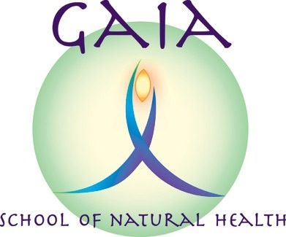
INTRODUCTION TO REFLEXOLOGY
Information and Booking Form

Led by: CAROLYN ROBERTS MAR MSc PRM. Principal of Gaia School of Natural Health
Date: Thursday 19th March 2020
Time: 10.00am – 4.00pm
Venue: The Women's Institute, Neston Road, Thornton Hough,
South Wirral, CH63 1JW.

A hands on class that offers an enjoyable introduction to the complementary therapy of reflexology. The one day workshop will enable participants to give simple treatments to family and friends. It will not qualify you to practice as a reflexologist.

Course Structure

The course includes:

• What is reflexology and how does it work?
• Foot relaxation techniques
• The reflex positions on the foot
• A basic reflexology treatment
• How reflexology can help you and your friends
• Different reflexology techniques

How do I book?

Please complete and return the slip attached with your non-refundable deposit for £25 to Gaia School of Natural Health. The deposit is non-refundable unless the course is cancelled by the Gaia School. The form can be e-mailed back, and the deposit can be paid online.
INTRODUCTION TO REFLEXOLOGY BOOKING FORM

Course Date | Thursday 19th March 2020
Course fee | £65 per person
Course times | 10.00am – 4.00pm
Closing date for bookings: Thursday 12th March 2020

Please make a bank transfer for £25 non-refundable deposit (balance of £40 to be paid on the day) to “Gaia School of Natural Health” Sort code: 089299. Account No.: 69643259
Or please make cheques payable to “Gaia School of Natural Health” and send with booking form to 15 Grange Crescent, Childer Thornton, S. Wirral, CH66 5NA.

PLEASE PRINT IN BLOCK CAPITALS
Name:
E-mail:
Phone No.:
Address:

Date of birth:

Please provide name and phone number of an Emergency Contact:

Please indicate here if you have any health or learning issues which might affect your ability to give or receive a reflexology treatment.

Consent signature
This is to confirm that you have read the Gaia School of Natural Health (GSNH) privacy notice (as indicated when originally downloading this form), and consent to GSNH holding and using the personal information being provided in this form, for the purposes outlined in the Gaia School privacy notice.

Signature:

